20th PROCESS INTENSIFICATION NETWORK (PIN) MEETING
'What's New in PI 2012?'
The Beehive, Newcastle University, 2 May 2012
Meeting Minutes
The 20th PIN Meeting was held at Newcastle University on 2 May 2012. This was the first time we had used the services of the IChemE to put the meeting together and to make arrangements. There was a very modest attendance, but those there heard several very good talks on a wide range of PI topics from speakers from the UK and overseas. There was also a tour of the PI laboratories in Chemical Engineering at the University.
Some abstracts of the talks given are appended (including one abstract from Professor Fei, who was unable to attend). The presentation overheads for most of the talks are being put on the PIN web site (www.pinetwork.org).
Please note that feedback from PIN members is invited - see a reference to this in the 'Conclusions'.
Adam Harvey, recently appointed Professor of Process Intensification, welcomed PIN members to the University.
Technical Sessions
Higee - Developments at ICI
The first presentation, fittingly, was by Jim Wem who was associated with the design, construction and testing of the first Higee machine at ICI, commencing in 1978. Jim's abstract is given in the Appendix, and the data below are based upon notes made during the meeting. The photo here (there are numerous others on the PIN web site) shows the rotor of Higee at ICI.
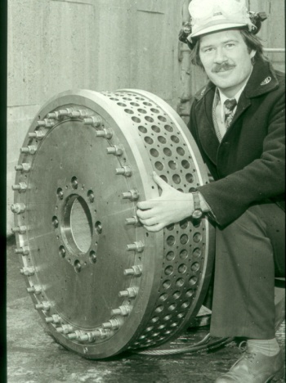
The Higee Rotor at ICI
Jim started working on Higee in 1978, the original suggestion being the Broadbent, a centrifuge manufacturer, would make the Higee machine. The original concept considered a number of stacked stages, but this was fund to be difficult to implement. The design of the rotor led to a diameter of 800 mm o.d. and 150 mm in width. However in order to progress an end use was needed. The group examined the distillation columns being used in ICI Petrochemicals Division, and of the 60 being considered, 39 could use Higee, therefore they could fund the building of a unit. Detail design was handed to Broadbents and a go-ahead was given to construct the unit in June 1980. 18 months later it was constructed at a cost of £1.2 million. The unit weighed 40 t and was in stainless steel. Operating rotational speed was 1800 rpm. A smaller rotor was also constructed that could run at higher speed.
The unit was operated with a vertical shaft and the machine was design for 22 bar, as no columns operated at a pressure greater than 21 bar. Jenkins of Rotherham made the high pressure unit.
The design performance was achieved, getting 18 stages in 300 mm height. Retimet (a Dunlop metal foam) was used. This had a surface area density of 2000m²/m³ and was preferable to the other packing considered - Knitmesh - that was found to be difficult to pack. Alternative casing designs were examined.
The concept found a use for cleaning the air in submarine (including CO₂ removal! It had to withstand a 35g acceleration test and the machine was exhibited in the Science Museum in London. (See Jim's photo selection on the PIN web site).
With regard to distillation applications of Higee, Jim said that they concluded that the best place to use it was offshore, but before doing this they needed 10 years experience onshore. One idea was to try it at the BP onshore plant at Wytch Farm in Dorset, but this came to nought.
The Coflore Reactor - An Update
Gilda Gasparini of AM Technology (gilda.gasparini@amtechuk.com) described the Coflore reactor, illustrated below (see the full presentation on the PIN web site for further data).
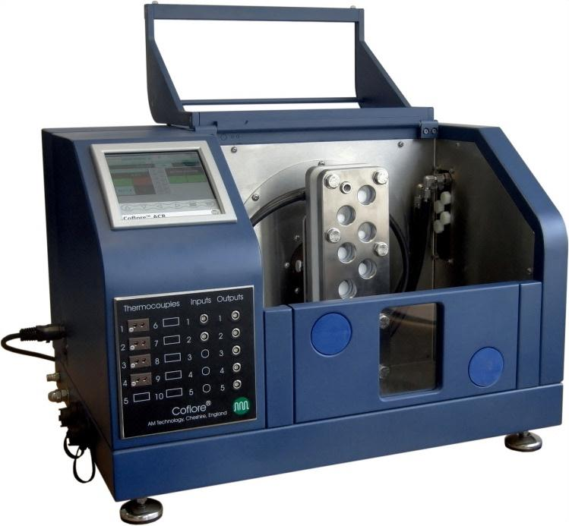
Gilda stressed the benefits of moving from batch to continuous processing, and highlighted the fact that the Coflore unit is essentially Continuous Stirred Tank Reactors (CSTRs) in series. They involve dynamic mixing - an external system providing the mixing ('agitators' in a shaken reactor) - and can achieve plug flow. The CSTR can work with solids, and examples were given of this. It is easy to scale up.
Industrial scale units are in the 1 - 10 litre range and there may be ten temperature control zones.
In the presentation there are number of applications discussed. there are upwards of 24 machines in the field now, dealing with solids, polymerisation and high viscosity fluids, amongst others.
Solar Process Heat for Production and Advanced Applications

Christoph Brunner co-ordinates a number of activities relating solar energy applications, and these are of considerable potential interest to PIN members. His paper abstract (see Appendix) and the presentation on the web site give full data, but of particular interest is the IEA (International Energy Agency) Solar Heating & Cooling Task 49/IV subtask B, and the section below is taken from Subtask B on the IEA web site (the italics are mine):
"Based on the foreseen topics Subtask B will be based upon the following structure:
- Advanced integration (pinch analysis and storage management, decision where to integrate solar heat on industrial site)
  - Integration on temperature levels up to 400°C, methodology for decision on integration types incl. thermodynamic and cost factors
    - Integration at process level, at distribution level, combined integration for several processes, combined integration with other heat sources
    - Integration methodology: focus on (mis)match between supply and demand
    - Consideration of material aspects, specific heat transfer requirements concerning process fluids
  - Definition of requirements of necessary “components” for system integration (e.g. advanced heat exchangers, advanced system control strategies, collectors (stagnation issues, load profiles, temperature) [link to subtask A])
- Combining Process Intensification technologies and Solar process heat:
  - For existing processes
  - In new applications (not limited to thermal processes)
"In general Subtask B will focus on following main objectives:
- Improved solar thermal system integration for production processes by advanced heat integration and storage management, advanced methodology for decision on integration place and integration types
- Increase of the solar process heat potential by combining process intensification and solar thermal systems and fostering new applications for solar (thermal/UV) technologies"
Christoph said that in the EU27 thermal energy needs are 49% of total energy demand, of which industry needed 30% of the total at temperatures >250ºC and 14% of the total at <250ºC. In the EU25 the potential from solar energy is 70 TWh/year at less than 250ºC, or 3-4% of the total thermal energy demand in Europe. Further statistics are given in the presentation.
Integrated Process Intensification for Sustainable Ammonia and Biofuel Production: Demonstration Plant Development
Galip Akay of CEAM at Newcastle University gave a summary of intensified unit operations developed for ammonia and biofuel production - see the Appendix for the Abstract section leading in to this. These unit operations are generic and now integrated to obtain a novel ammonia production process from biomass through gasification. An ammonia demonstration plant is currently under construction by ITI Energy (www.iti-energy.com) with funding from an EU FP7- project (COPIRIDE) with further funding for catalyst development from another EU FP7-project (POLYCAT). This integrated technology is based on some 12 patents and patent applications covering the whole processes, catalysts and materials used in the ammonia and gas-to-liquid conversion processes. Most of the intensified unit operations and their integration mimic the human physiology operating at ambient pressures and relatively low temperatures. The ammonia plant is also integrated with agriculture in which NSMP-polymers used initially in syngas and process water cleaning are used as soil additives acting as synthetic rhizo-sphere (SRS) where the growing plant roots interact with water, nutrients and bacteria in a micro-environment to enhance water and mineral uptake and fix nitrogen from the air. As a result, crop yield is enhanced in the range of 50-300% especially under water and nutrient stress. Therefore, the use of SRS-media results in AgroProcess Intensification which allows the use of marginal land under water stress. SRS-media is generated as part of the ammonia production thus making both ammonia and SRS-media production sustainable. Our current research now concentrates on gas-to-liquid conversion applied to both biomass and natural gas as well as extension of supported catalyst production and AgroProcess Intensification which requires basic chemical engineering input for further advancement.
An interesting point that Galip mentioned as the use of a capillary reactor with a surface area density of 10,000 m²/m³ from the USA. He pointed out that the cost of a commercial gasifier was of the order of £6 million/MWe, while his intensified unit was around £2 million/MWe.
Post-combustion Carbon Capture Research at Newcastle University
Although Professor Weiyang Fei was unable to travel from China to present his talk on intensification of carbon capture (his abstract is retained in the minutes for information) we were given an enlightening talk by Jon Lee, who leads the CC research using PI at Newcastle.
Jon started by describing some of the earlier research carried out at Newcastle on rotating packed beds for carbon capture. One interesting aspect of this was the fact that an RPB could handle very strong MEA solutions - up to 100% as shown in the data in the graph below, and CO₂ removal increased with increasing MEA strength. As Jon pointed out, it is not possible to use higher strength MEA (30% is the typical limit) in static absorber columns because of the increasing viscosity with concentration.
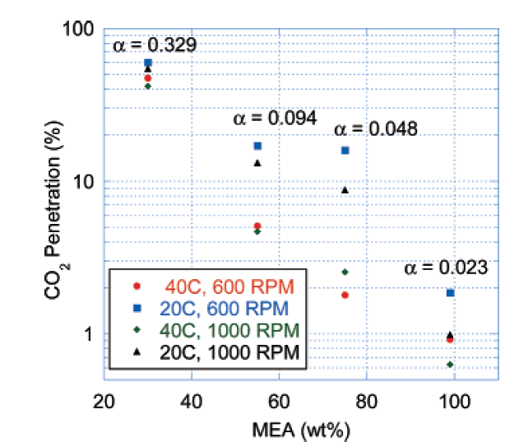
A number of important conclusions were made as a result of this research (references are available in Jon's presentation on the PIN web site), not least being the fact that RPBs enhance CO₂ absorption by a factor of between 10 to 100.
Jon then described the current work on RPBs for carbon capture, showing how measurements on the rig currently being assembled would be made - in particular for bed pressure drop and liquid distribution. Photos are given in the presentation.
Design of a Catalytic Membrane Reactor for the Oxidative Coupling of Methane
Fausto Gallucci, from Eindhoven University of Technology, discussed the work at Eindhoven on catalytic membrane reactors. The main application was the production of ethylene from natural gas.
The ultimate aim would be to have direct production from methane, via oxidative coupling, but at present the yield and conversion are rather low, and need to be increased.
One solution suggested by Fausto was an autothermal process carried out in a single multifunctional reactor, such as the unit shown below.
Full data are given in the slides on the PIN web site.
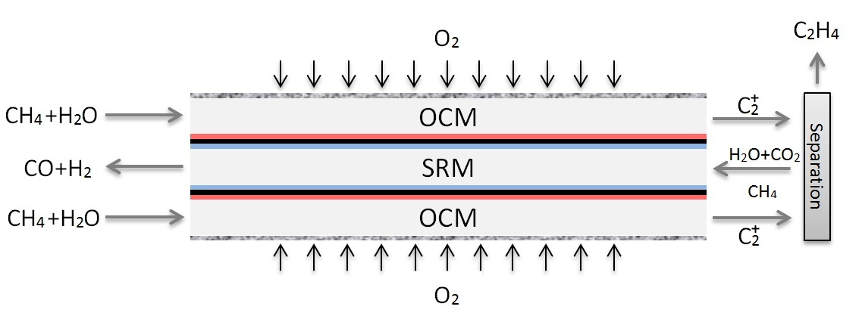
'IMPROMPTU' PRESENTATIONS
There were a number of impromptu presentations, and those from Newcastle University (Anh Phan) and TNO (Jean-Marie Bassett) are on the PIN web site. Jeremy Double of BRITEST also updated us on the EU FP7 PILLS project, which is nearing its conclusions.
Anh Phan from Newcastle gave a talk on a process platform for rapid screening, based upon oscillatory flow reactors. The advantages of using these are several, listed below;
- Operate at very low net flow rates: from µl/hr to ml/hr (residence time : mins to hours)
- Reduce amount of reagents and waste
- Suitable for viscous liquid and multiphase reactions (solid-liquid, gas-liquid and solid-solid-liquid)
- Suitable for continuous high throughput screening & small scale pharmaceutical production
Jean-Marie Bassett discussed a number of PI projects being undertaken in the TNO laboratories. These included the Helix Reactor, illustrated below before assembly, membrane reactors and wok on the manifolding of micro-reactors, an important area for successful functioning of these. There are substantial data on these, and more, in the presentations on the PIN web site.
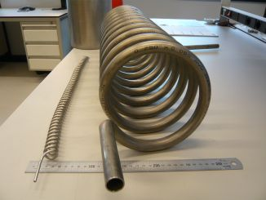

Conclusions
During the lunch break there was a tour of the PI laboratories at Newcastle. There were a number of points raised later: the IChemE mentioned that the 4th European PI Conference will be absorbed into ECCE9, in The Hague. See www.ecce2013.eu/ for full data - the meeting is from 21-24th April 2013. The call for abstracts is now live and closes 15 November. Topic 14 is Process Intensification.
Adam Harvey and I would value feedback on the meeting and what you would like regarding organisation/venues/programmes/frequency of meetings. Please contact us on David.Reay@newcastle.ac.uk or Adam.Harvey@newcastle.ac.uk
We propose to hold the next meeting at Newcastle, thereafter moving around the country. We will inform you of a date as soon as we make our plans.
If you missed the last on-line HEXAG/PIN Newsletter, please post the address below in your browser.
http://www.hexag.org/newsletter/index.html
We will be compiling another issue once the 2nd Edition of the Process Intensification book (the one by Colin Ramshaw, Adam Harvey and me) is completed - around the end of August. Information/case studies etc. are welcome for either the book or the Newsletter (or both).
Please send any data to me, David Reay, on DAReay@aol.com or David.Reay@newcastle.ac.uk .

A selection of abstracts is on the next pages:

APPENDIX
ABSTRACTS OF A SELECTION OF TALKS
Designing building and operating the first commercial size HiGee machine set.
Jim Wem, Lately ICI and then Du Pont Principal Machines Consultant
The set consisted of two independent rotors each 800 mm OD and 200 mm ID and each driven by a shaft mounted hydraulic motor which gave us a variable speed capacity. We also built two smaller OD rotors which allowed us to achieve a higher acceleration. We eventually obtained an HETP of about 15 mm i.e. the equivalent of 20 plates in each rotor. The shafts were mounted vertically to ensure the liquid discharged from each rotor was as far from the rotor as practicable. The casings were designed for higher pressure than usual in a centrifuge casing
My Chemical Engineering colleagues wanted a temperature profile measured across the packing at about 8 or 10 points to allow them to determine the ‘separation’ capacity. I called it ‘separation’ as I was the ICI Centrifuge expert at the time and Chairman of the BSI Centrifuge committee.
I was unable to find a system good enough to measure that temperature profile at a cost I could afford as the project engineer. My Instrument Engineer colleagues suggested we used a gas chromatograph system with multiple sample points with scanning valves to measure directly the inlet and discharge values.
This necessitated a computer with a capacity that was very large at the time to solve the equations. We could therefore say what was happening more or less instantaneously rather than wait for lab analyses some hours later.
Initial results were discouraging until I moved the liquid feed closer to the packing inner surface .
The Project cost was £1.2m. It was built as a free standing unit complete with boiler, pumps and storage. It weighed about 40 tonnes and had an adjacent separate cooling tower. The computer, gas chromatograph and other control equipment was in a portacabin some 20 metres away
Process intensification through Coflore flow reactors
Paul David Dickson (paper presented by Gilda Gasparini)
AM Technology, The Heath Business and Technical Park, Runcorn WA7 4QX
p_dickson@ntlworld.com
The utilisation of continuous flow reactors over batch reactors is one way of intensifying the reaction part of a process; through enhanced control of the reactor, greater energy efficiency and reduced operational costs.
This presentation will provide an insight into AM Technology’s range of Coflore continuous flow reactors. Examining the design principles, incorporation of multistage reactors to achieve plug flow behaviour and the use of patented transverse dynamic mixing regimes to achieve efficient velocity independent mixing. In addition showing how this combination delivers greater control over residence times for a fixed volume reactor, multi-phasic handling capabilities and low pressure drops through the reactor system.
Practical examples will also be given demonstrating the flexible and adaptable nature of the Coflore design, the ease in which Coflore reactors can be scaled up and the potential benefits these systems can offer over batch reactors.
Solar process heat for production and advanced applications

Christoph Brunner

AEE INTEC - Institute for Sustainable Technologies, 8200 Gleisdorf, Feldgasse 19, Austria

c.brunner@aee.at

The content of this new proposed project were defined based on this knowledge out of IEA SHC 33/Solar Paces Task IV and other position papers like the strategic research agenda of the European Solar Thermal Technology Platform and the experience of several national projects in the field of solar process heat.

The main goals of the activity will be to investigate:

Process Heat Collectors:
· Improving solar process heat collectors and collector loop components.
· Providing a basis for the comparison of collectors with respect to technical and economical conditions.
· Giving comprehensive recommendations for standardized testing procedures

Process Integration and Process Intensification Combined with Solar Process Heat:
· Improved solar thermal system integration for production processes by advanced heat integration and storage management, advanced methodology for decision on integration place and integration types.
· Increase of the solar process heat potential by combining process intensification and solar thermal systems and fostering new applications for solar (thermal/UV) technologies.

Design Guidelines, Case Studies and Dissemination:
· To provide a worldwide overview of results and experiences from solar heat for industrial process systems(including completed and ongoing demonstration system installations using monitoring data, as well as carrying out economic analyses) in order to lower the barriers for market deployment and to disseminate the knowledge to the main target groups involved.
· To develop a performance assessment methodology for a comparison and analysis of different applications, collector systems, regional and climatic conditions.
· To support future project stakeholders by providing design guidelines, simplified fast and easy to handle calculation tools for solar yields and performance assessment.
· To investigate system solutions for stagnations behaviour, control and hydraulics of large field installations.

Integrated Process Intensification for Sustainable Ammonia and Biofuel Production: Demonstration Plant Development
Galip Akay
Chemical Engineering & Advanced Materials (CEAM), Newcastle University, Merz Court, Newcastle upon Tyne NE1 7RU
Galip.Akay@newcastle.ac.uk
The attributes of Process Intensification (PI) are highly suitable for biomass based sustainable energy, fuel and chemical production which needs to be carried out in small scale distributed facilities since biomass/waste feed stock is also distributed. The full potential of PI can only be realised if intensified unit operations are integrated at chemical/biochemical plant level as well as on a global scale to achieve holisticity. However, the generation of biomass as feedstock should not interfere with food and water supplies and it should infact be integrated with food, energy and water generation. Such an integration will shift power, fuel and chemical production from crude-oil refineries to bio-refineries thus combating global warming and food, energy and water shortages.
We have been developing several patented intensified processes, reactors, reactive membranes and materials for the establishment of an Integrated Intensified Biorefinery (IIBR)- technology. The individual intensified unit operations and elements of IIBT include:
1) Gasifier and OxyGasifier; 2) Syngas cleaning; 3) High temperature gas separation; 4) Syngas–to-Liquid conversion processes (ammonia, ethanol and biofuels); 5) Nano-structured micro-porous (NSMP) materials for reactor fabrication and catalyst support; 6) Novel supported catalysts for intensified reactors.
Design of a Catalytic Membrane Reactor for the Oxidative Coupling of Methane
Fausto Gallucci
Eindhoven University of Technology, Eindhoven, 5600 MB , The Netherlands
+31 40 247 3675
f.gallucci@tue.nl
Packed bed membrane reactors (PBMRs) for the distributive addition of oxygen are efficient reactor concepts for selectivity enhancements in partial oxidation systems. Low oxygen concentration levels in the PBMR results in improved product selectivities for reaction systems in which the oxygen concentration dependency of the target product is smaller than that of the waste product. Oxidative coupling of methane (OCM) for the production of ethylene is an industrially relevant case for which membrane reactors can be successfully applied. This work, reports the design of a packed bed membrane reactor for the OCM, based on kinetic experiments and membrane flux measurements.
La2O3-SrO/CaO catalyst is the most promising among all catalysts because of its high activity, selectivity and thermal/hydrothermal stability (Choudhary and Uphade, 2004) and hence shows a great promise for their use in a commercial process. In this work, the La2O3-SrO/CaO catalyst was prepared by the wet impregnation method. Prior to performing kinetic experiments the catalyst was crushed and sieved to obtain the fraction with required particle size. The rates of reactions prevailing during the OCM were measured under differential conditions in a quartz micro-catalytic fixed bed reactor. The overall reaction orders and rate constants of the primary reactions were determined by measuring the intrinsic reaction rates at different methane and oxygen inlet concentrations. Based on the experiments and least-squares minimization, a simplified reaction mechanism is proposed.
Furthermore, porous membranes, which are mechanically and chemically stable at high temperatures, were applied. Macro-porous support tube made of 99.7 wt% a-Al2O3 with a thin mesoporous layer (made of a-Al2O3) coated inside of the tube with an average pore diameter ranging from 5-1400 nm, were used and the membrane flux was measured as a function of membrane pressure difference. The flux measurements of membranes were used to determine the permeability parameters by Dusty Gas Model.
Subsequently, a heterogeneous packed bed reactor model was developed for OCM on La2O3-SrO/CaO catalyst, which consists of two cylindrical compartments separated by inorganic porous membrane through which the O2 is distributed to the catalyst bed. The PBMR model is capable to account for the influence of the intraparticle concentration and temperature profiles on the bulk gas phase composition and temperature. The OCM kinetics and O2 flux measurements were used to determine the operating conditions of packed bed membrane reactor by means of numerical simulations.
Reference
Choudhary, V. R. and Uphade, B. S. Oxidative conversion of methane/natural gas into higher hydrocarbons, Catalysis Surveys from Asia 8 (2004), 15–25.
Studies on PI of CO2 Capture by Hybrid Technologies (PAPER NOT PRESENTED)
Weiyang FEI
Tsinghua.University, No.1, Tsinghua Yuan, Beijing 100084, China
8613911114485
fwy-dce@tsinghua.edu.cn
Global warming, caused by greenhouse gases, has become a key environmental problem. Developing advanced, affordable CCS technology is one of the main challenges for Chemical Engineering. Therefore, it is necessary to study PI of CO2 Capture by hybrid technologies to reduce its cost significantly. Studies on PI of CCS in Chinese universities and research institutes are reviewed and two case studies are introduced as follows,
Case study 1: Study on PI of Pre- Combustion CO2 Capture by Hybrid Technology
IGCC combined with Pre-Combustion CO2 Capture suppose to be the best clear coal technology. However, the existing CO2 Capture approaches are still far too expensive. Two “green” absorbent, Dimethyl Carbonate (DMC) and Diethyl Carbonate (DEC), was proposed as new solvents. The Plum Flower Mini Ring (PFMR) was proposed as the column internal instead of Mellapak. The feasibility of using per-vaporization for solvent regeneration was studied. It is shown from the simulation that cost of the hybrid process might decrease substantially compared with the existing ones.
Case Study 2: Development of high efficiency column internals for CO2 Capture
All CO2 Capture processes (for post-combustion, pre-combustion, or oxygen combustion) need extra large separation equipments. The investment of separation processes will be huge. Therefore, a hybrid approach (CFD simulation + DPIV measurement + reliable experiments) was used for developing high efficiency absorption column internals. The characteristics and performance of Plum Flower Mini Ring (PFMR) and a new Small Corrugation Angle Structured Packing are described. It is shown from the experimental data and commercial applications that the performance of these new column internals is much better than those of the conventional ones.
Minutes prepared by David Reay,
Completed 30 May 2012.
+++++++

